Morning Prayer
Gospel Canticle Luke 1:68-79

Blessed be the Lord, the God of Israel;
he has come to his people and set them free.

He has raised up for us a mighty savior,
born of the house of his servant David.

Through his holy prophets he promised of old
that he would save us from our enemies,
from the hand of all who hate us.

He Promised to show mercy to our fathers
and to remember his holy covenant.

This was the oath he swore to our father Abraham:
to set us free from the hands of our enemies,
free to worship him without fear,
holy and righteous in his sight all the days of our life.

You, my child, shall be called the prophet of the Most High;
for you will go before the Lord to prepare his way,
to give his people knowledge of salvation
by the forgiveness of their sins.

In the tender compassion of our God
the dawn from on high shall break upon us,
to shine on those who dwell in darkness
and the shadow of death,
and to guide our feet into the way of peace.

Invitatory - Psalm 95
Come, let us sing to the Lord
and shout with joy to the Rock who saves us.
Let us approach him with praise and thanksgiving and sing joyful songs to the Lord.

The Lord is God, the mighty God,
the great king over all the gods.
He holds in his hands the depths of the earth
and the highest mountains as well
He made the sea; it belongs to him,
the dry land, too, for it was formed by his hands.

Come, then, let us bow down and worship,
bending the knee before the Lord, our maker,
For he is our God and we are his people,
the flock he shepherds.

Today, listen to the voice of the Lord:
Do not grow stubborn, as your fathers did
in the wilderness, when at Meriba and Massah
they challenged me and provoked me,
Although they had seen all of my works.

Forty years I endured that generation.
I said, “They are a people whose hearts go astray
and they do not know my ways.
So I swore in my anger,
“They shall not enter into my rest.”

Evening Prayer
Gospel Canticle Luke 1:46-55

My soul proclaims the greatness of the Lord
my spirit rejoices in God my savior
for He has looked with favor on His lowly
servant.

From this day all generations will call me blessed:
the Almighty has done great things for me
and holy is His Name.

He has mercy on those who fear Him
in every generation

He has shown the strength of His arm
He has scattered the proud in their conceit

He has cast down the mighty from their thrones
and has lifted up the lowly

He has filled the hungry with good things
and the rich He has sent away empty

He has come to the help of His servant Israel
for He has remembered His promise of mercy

the promise He made to our fathers
to Abraham and His children for ever

TE DEUM
You are God: we praise you;
You are the Lord; we acclaim you;
You are the eternal Father:
All creation worships you.

To you all angels, all the powers of heaven,
Cherubim and Seraphim, sing in endless praise:
Holy, holy, holy Lord, God of power and might,
heaven and earth are full of your glory.

The glorious company of apostles praise you.
The noble fellowship of prophets praise you.
The white-robed army of martyrs praise you.

Throughout the world the holy Church acclaims you;
Father, of majesty unbounded,
your true and only Son, worthy of all worship,
and the Holy Spirit, advocate and guide.

You, Christ, are the king of glory,
the eternal Son of the Father.
When you became man to set us free
you did not shun the Virgin's womb.

You overcame the sting of death
and opened the kingdom of heaven to all believers.
You are seated at God's right hand in glory.
We believe that you will come and be our judge.

Come then, Lord, and help your people,
bought with the price of your own blood,
and bring us with your saints
to glory everlasting.

O Sacred Banquet

O Sacred Banquet,
in which Christ is received,
the memory of His Passion is recalled,
the soul is filled with grace,
and the pledge of future glory is given to us

Salve Regina
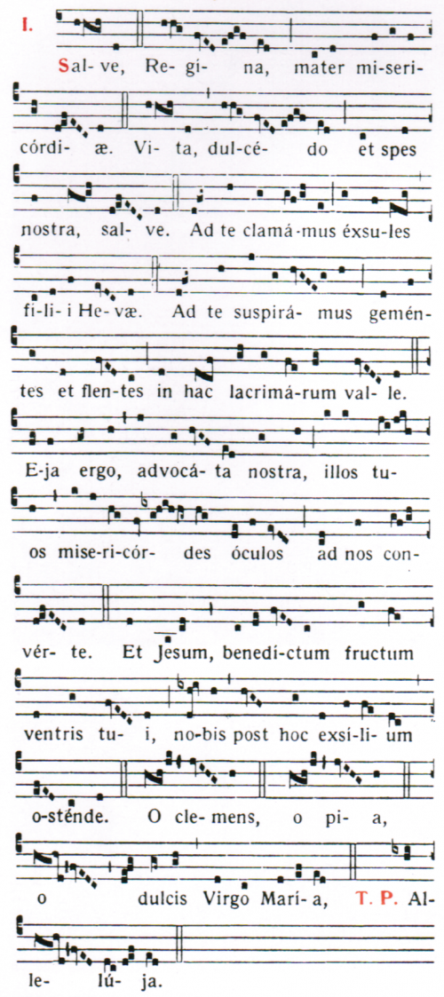

Salve Regina, Mater misericordiae,
Vita dulcedo et spes nostra salve.
Ad te clamamus exsules filii Hevae.
Ad te suspiramus gementes et flentes,
in hac lacrimarum valle.
Eja ergo advocata nostra,
illos tuos misericordes oculos ad nos converte.
Et Jesum benedictum fructum ventris tui
nobis post hoc exsilium ostende.
O clemens, o pia, o dulcis Virgo Maria.
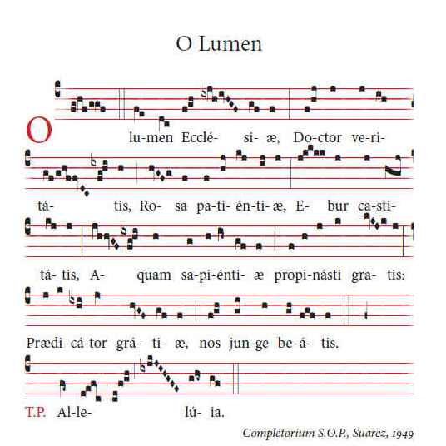
O Light of the Church,
Teacher of truth,
Rose of patience,
Ivory of chastity,
You freely offered
The waters of wisdom,
Preacher of grace,
Unite us with the blessed.

Liturgy of the Hours Outline

The character of Morning Prayer is that of praise;
of Evening Prayer, that of thanksgiving.
Both follow a similar format:

Opening verse (God come to my assistance…or (for Morning Prayer only Lord open my lips….and the invitatory)
Hymn is not done when praying privately as standing sitting and bowing are also not required in private
Two psalms, or parts of psalms with a scriptural canticle. The doxology (Glory be…. is said after each)
The Antiphon is said before and after each psalm or canticle and magnificat
Reading (It is simply read, and not introduced as being from a certain book etc.)
Responsorial, typically a verse of scripture,
Gospel Antiphon
Canticle taken from the Gospel of Luke: the Canticle of Zechariah (Benedictus) for morning prayer, and the Canticle of Mary (Magnificat) for evening prayer
Gospel Antiphon is repeated
Intercessions, composed by the Church
The Lord’s Prayer
A concluding prayer

